Name : Siddhant Mangale Class : B.Tech (A)

Roll No. : 31 Experiment No. : 8

Installed Widgets ───────────────── v0.6.6 Installed Adapt ─────────────────── v3.4.0 Installed StatsPlots ────────────── v0.15.4 Installed DualNumbers ───────────── v0.6.8 Installed Arpack_jll ────────────── v3.5.1+1 Installed MultivariateStats ─────── v0.10.0 Installed Rmath ─────────────────── v0.7.0 Installed TableOperations ───────── v1.2.0 Installed Arpack ────────────────── v0.5.4 Installed AxisAlgorithms ────────── v1.0.1 Installed WoodburyMatrices ──────── v0.5.5 Installed Observables ───────────── v0.5.4 Installed DensityInterface ──────── v0.4.0 Installed QuadGK ────────────────── v2.6.0 Installed NearestNeighbors ──────── v0.4.12 Installed Distributions ─────────── v0.25.77 Installed Clustering ────────────── v0.14.3 Installed Interpolations ────────── v0.14.6 Downloaded artifact: IntelOpenMP Downloaded artifact: Rmath

Downloaded artifact: FFTW Downloaded artifact: FFTW

ERROR: Unable to automatically download/install artifact 'FFTW' from sources listed in 'C:\Users\aniket\.julia\packages\FFTW_jll\kayS2\Artifacts.toml'.

Sources attempted:

* https://pkg.julialang.org/artifact/b7dd1809d0626eac3bf6f97ba8ccfbb6cc63c509

Error: HTTP/1.1 200 OK (Operation too slow. Less than 1 bytes/sec transferred the last 20 seconds) while requesting https://pkg.julialang.org/artifact/b7dd1809d0626eac3bf6f97ba8ccfbb6cc63c509

* https://github.com/JuliaBinaryWrappers/FFTW_jll.jl/releases/download/FFTW- v3.3.10+0/FFTW.v3.3.10.x86_64-w64-mingw32.tar.gz

Error: HTTP/1.1 200 OK (Operation too slow. Less than 1 bytes/sec transferred the last 20 seconds) while requesting https://github.com/JuliaBinaryWrappers/FFTW_jll.jl/releases/download/FFTW- v3.3.10+0/FFTW.v3.3.10.x86_64-w64-mingw32.tar.gz

julia> using StatsPlots

│ Package StatsPlots not found, but a package named StatsPlots is available from a registry.

│ Install package?

│ (@v1.8) pkg> add StatsPlots

└ (y/n/o) [y]: y

Resolving package versions... Downloaded artifact: FFTW Downloaded artifact: Arpack

Updating `C:\Users\aniket\.julia\environments\v1.8\Project.toml` [f3b207a7] + StatsPlots v0.15.4

Updating `C:\Users\aniket\.julia\environments\v1.8\Manifest.toml` [621f4979] + AbstractFFTs v1.2.1

[79e6a3ab] + Adapt v3.4.0 [7d9fca2a] + Arpack v0.5.4 [13072b0f] + AxisAlgorithms v1.0.1 [49dc2e85] + Calculus v0.5.1 [aaaa29a8] + Clustering v0.14.3 [e7dc6d0d] + DataValues v0.4.13 [b429d917] + DensityInterface v0.4.0 [b4f34e82] + Distances v0.10.7 [31c24e10] + Distributions v0.25.77 [fa6b7ba4] + DualNumbers v0.6.8 [7a1cc6ca] + FFTW v1.5.0

[34004b35] + HypergeometricFunctions v0.3.11 [a98d9a8b] + Interpolations v0.14.6 [5ab0869b] + KernelDensity v0.6.5

[6f286f6a] + MultivariateStats v0.10.0 [b8a86587] + NearestNeighbors v0.4.12 [510215fc] + Observables v0.5.4 [6fe1bfb0] + OffsetArrays v1.12.8 [90014a1f] + PDMats v0.11.16

[1fd47b50] + QuadGK v2.6.0 [c84ed2f1] + Ratios v0.4.3 [79098fc4] + Rmath v0.7.0 [4c63d2b9] + StatsFuns v1.0.1 [f3b207a7] + StatsPlots v0.15.4 [ab02a1b2] + TableOperations v1.2.0 [cc8bc4a8] + Widgets v0.6.6

[efce3f68] + WoodburyMatrices v0.5.5

⌅ [68821587] + Arpack_jll v3.5.1+1 [f5851436] + FFTW_jll v3.3.10+0

[1d5cc7b8] + IntelOpenMP_jll v2018.0.3+2 [856f044c] + MKL_jll v2022.2.0+0

[f50d1b31] + Rmath_jll v0.3.0+0 [4af54fe1] + LazyArtifacts

Info Packages marked with ⌅ have new versions available but cannot be upgraded. To see why use `status --outdated -m`

Precompiling project...

✗ PyCall

✗ PyPlot

33 dependencies successfully precompiled in 25 seconds. 179 already precompiled.

2 dependencies errored. To see a full report either run `import Pkg; Pkg.precompile()` or load the packages

julia> plotly()

[ Info: For saving to png with the Plotly backend PlotlyBase and PlotlyKaleido need to be installed. Plots.PlotlyBackend()

julia> train=CSV.read("C:/Users/aniket/OneDrive/Desktop/loan.csv",DataFrame,normalizenames=true)

614×13 DataFrame

Row │ Loan_ID Gender Married Dependents Education Self_Employed ApplicantIncome ⋯

│ String15 String7? String3? String3? String15 String3? Int64 ⋯

─────┼───────────────────────────────────────────────────────────────────────────

───────────────

|  |  |  |  |  |  |  |
| --- | --- | --- | --- | --- | --- | --- |
| 1 │ LP001002 Male | | No | 0 | Graduate | No | 5849 ⋯ |
| 2 │ LP001003 Male | | Yes | 1 | Graduate | No | 4583 |
| 3 │ LP001005 Male | | Yes | 0 | Graduate | Yes | 3000 |
| 4 │ LP001006 Male | | Yes | 0 | Not Graduate No | | 2583 |
| 5 │ LP001008 Male | | No | 0 | Graduate No | | 6000 ⋯ |
| 6 │ LP001011 Male | | Yes | 2 | Graduate Yes | | 5417 |
| 7 │ LP001013 Male | | Yes | 0 | Not Graduate No | | 2333 |
| 8 │ LP001014 Male | | Yes | 3+ | Graduate No | | 3036 |
| 9 │ LP001018 Male | | Yes | 2 | Graduate No | | 4006 ⋯ |
| 10 │ LP001020 | Male | Yes | 1 | Graduate | No | 12841 |
| 11 │ LP001024 | Male | Yes | 2 | Graduate | No | 3200 |
| 12 │ LP001027 | Male | Yes | 2 | Graduate | missing | 2500 |
| 13 │ LP001028 | Male | Yes | 2 | Graduate | No | 3073 ⋯ |
| 14 │ LP001029 | Male | No | 0 | Graduate | No | 1853 |
| 15 │ LP001030 | Male | Yes | 2 | Graduate | No | 1299 |
| 16 │ LP001032 | Male | No | 0 | Graduate | No | 4950 |

1. │ LP001034 Male No 1 Not Graduate No 3596 ⋯
2. │ LP001036 Female No 0 Graduate No 3510
3. │ LP001038 Male Yes 0 Not Graduate No 4887
4. │ LP001041 Male Yes 0 Graduate missing 2600
5. │ LP001043 Male Yes 0 Not Graduate No 7660 ⋯
6. │ LP001046 Male Yes 1 Graduate No 5955

⋮ │ ⋮ ⋮ ⋮ ⋮ ⋮ ⋮ ⋮ ⋱

|  |  |  |  |  |  |  |
| --- | --- | --- | --- | --- | --- | --- |
| 594 │ LP002936 | Male | Yes | 0 | Graduate | No | 3859 |
| 595 │ LP002938 | Male | Yes | 0 | Graduate | Yes | 16120 |
| 596 │ LP002940 | Male | No | 0 | Not Graduate No | | 3833 ⋯ |
| 597 │ LP002941 | Male | Yes | 2 | Not Graduate Yes | | 6383 |
| 598 │ LP002943 | Male | No | missing | Graduate No | | 2987 |
| 599 │ LP002945 | Male | Yes | 0 | Graduate Yes | | 9963 |
| 600 │ LP002948 | Male | Yes | 2 | Graduate No | | 5780 ⋯ |
| 601 │ LP002949 | Female | No | 3+ | Graduate missing | | 416 |
| 602 │ LP002950 | Male | Yes | 0 | Not Graduate missing | | 2894 |
| 603 │ LP002953 | Male | Yes | 3+ | Graduate No | | 5703 |
| 604 │ LP002958 | Male | No | 0 | Graduate No | | 3676 ⋯ |
| 605 │ LP002959 | Female | Yes | 1 | Graduate No | | 12000 |
| 606 │ LP002960 | Male | Yes | 0 | Not Graduate No | | 2400 |
| 607 │ LP002961 | Male | Yes | 1 | Graduate No | | 3400 |
| 608 │ LP002964 | Male | Yes | 2 | Not Graduate No | | 3987 ⋯ |
| 609 │ LP002974 | Male | Yes | 0 | Graduate No | | 3232 |
| 610 │ LP002978 | Female | No | 0 | Graduate No | | 2900 |
| 611 │ LP002979 | Male | Yes | 3+ | Graduate No | | 4106 |
| 612 │ LP002983 | Male | Yes | 1 | Graduate No | | 8072 ⋯ |
| 613 │ LP002984 | Male | Yes | 2 | Graduate No | | 7583 |
| 614 │ LP002990 | Female | No | 0 | Graduate Yes | | 4583 |

6 columns and 571 rows omitted

julia> train=dropmissing(train) 480×13 DataFrame

Row │ Loan_ID Gender Married Dependents Education Self_Employed ApplicantIncome C ⋯

│ String15 String7 String3 String3 String15 String3 Int64 F ⋯

─────┼───────────────────────────────────────────────────────────────────────────

───────────────

1 │ LP001003 Male Yes 1 Graduate No 4583 ⋯

|  |  |  |  |  |  |  |  |  |  |  |
| --- | --- | --- | --- | --- | --- | --- | --- | --- | --- | --- |
| 2 │ LP001005 Male | | | Yes | | | 0 | Graduate | Yes | | 3000 |
| 3 │ LP001006 Male Yes | | | | | | 0 | Not Graduate No | | | 2583 |
| 4 │ LP001008 Male No | | | | | | 0 | Graduate No | | | 6000 |
| 5 │ LP001011 Male Yes | | | | | | 2 | Graduate Yes | | | 5417 ⋯ |
| 6 │ LP001013 Male Yes | | | | | | 0 | Not Graduate No | | | 2333 |
| 7 │ LP001014 Male Yes | | | | | | 3+ | Graduate No | | | 3036 |
| 8 │ LP001018 Male Yes | | | | | | 2 | Graduate No | | | 4006 |
| 9 │ LP001020 Male Yes | | | | | | 1 | Graduate No | | | 12841 ⋯ |
| 10 │ LP001024 Male Yes | | | | | | 2 | Graduate No | | | 3200 |
| 11 │ LP001028 Male Yes | | | | | | 2 | Graduate No | | | 3073 |
| 12 │ LP001029 Male No | | | | | | 0 | Graduate No | | | 1853 |
| 13 │ LP001030 Male Yes | | | | | | 2 | Graduate No | | | 1299 ⋯ |
| 14 │ LP001032 Male No | | | | | | 0 | Graduate No | | | 4950 |
| 15 │ LP001036 Female No | | | | | | 0 | Graduate No | | | 3510 |
| 16 │ LP001038 Male Yes | | | | | | 0 | Not Graduate No | | | 4887 |
| 17 │ LP001043 Male Yes | | | | | | 0 | Not Graduate No | | | 7660 ⋯ |
| 18 │ LP001046 Male Yes | | | | | | 1 | Graduate No | | | 5955 |
| 19 │ LP001047 Male Yes | | | | | | 0 | Not Graduate No | | | 2600 |
| 20 │ LP001066 Male Yes | | | | | | 0 | Graduate Yes | | | 9560 |
| 21 │ LP001068 Male Yes | | | | | | 0 | Graduate No | | | 2799 ⋯ |
| 22 │ LP001073 Male Yes | | | | | | 2 | Not Graduate No | | | 4226 |
| ⋮ │ ⋮ | ⋮ | ⋮ | ⋮ | ⋮ | | | ⋮ | ⋮ | ⋱ | |
| 460 │ LP002917 | | Female | | | No | 0 | Not Graduate No | | | 2165 |
| 461 │ LP002926 | | Male | | | Yes | 2 | Graduate Yes | | | 2726 |
| 462 │ LP002928 | | Male | | | Yes | 0 | Graduate No | | | 3000 ⋯ |
| 463 │ LP002931 | | Male | | | Yes | 2 | Graduate Yes | | | 6000 |
| 464 │ LP002936 | | Male | | | Yes | 0 | Graduate No | | | 3859 |
| 465 │ LP002938 | | Male | | | Yes | 0 | Graduate Yes | | | 16120 |
| 466 │ LP002940 | | Male | | | No | 0 | Not Graduate No | | | 3833 ⋯ |
| 467 │ LP002941 | | Male | | | Yes | 2 | Not Graduate Yes | | | 6383 |
| 468 │ LP002945 | | Male | | | Yes | 0 | Graduate Yes | | | 9963 |

|  |  |  |  |  |  |  |
| --- | --- | --- | --- | --- | --- | --- |
| 469 │ LP002948 | Male | Yes | 2 | Graduate | No | 5780 |
| 470 │ LP002953 | Male | Yes | 3+ | Graduate | No | 5703 ⋯ |
| 471 │ LP002958 | Male | No | 0 | Graduate | No | 3676 |
| 472 │ LP002959 | Female | Yes | 1 | Graduate | No | 12000 |
| 473 │ LP002961 | Male | Yes | 1 | Graduate | No | 3400 |
| 474 │ LP002964 | Male | Yes | 2 | Not Graduate No | | 3987 ⋯ |
| 475 │ LP002974 | Male | Yes | 0 | Graduate No | | 3232 |
| 476 │ LP002978 | Female | No | 0 | Graduate No | | 2900 |
| 477 │ LP002979 | Male | Yes | 3+ | Graduate No | | 4106 |
| 478 │ LP002983 | Male | Yes | 1 | Graduate No | | 8072 ⋯ |
| 479 │ LP002984 | Male | Yes | 2 | Graduate No | | 7583 |
| 480 │ LP002990 | Female | No | 0 | Graduate Yes | | 4583 |

6 columns and 437 rows omitted

julia> Plots.histogram(train[!,"ApplicantIncome"],bins=50,xlabel="ApplicantIncome",labels="Frequency")

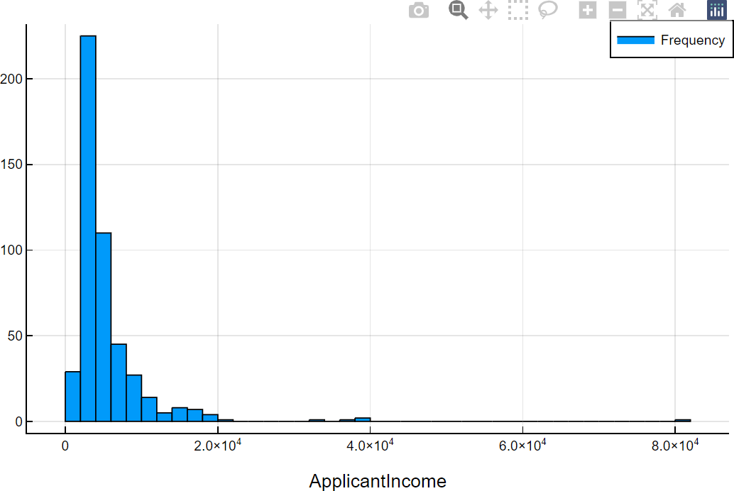

julia> using StatsPlots

julia> StatsPlots.boxplot(train[!,"ApplicantIncome"],xlabel="ApplicantIncome")

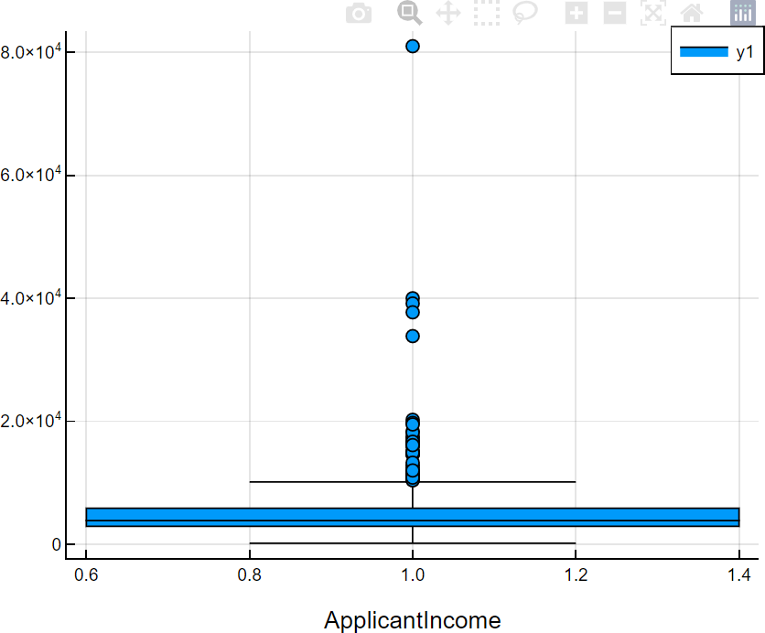

julia> StatsPlots.scatter(train[!,"LoanAmount"],train[!,"ApplicantIncome"],xlabel="LoanAmount",ylabel="A pplicantIncome")

